AN EXCEL BASED TELE COM CUSTOMER CHURN ANALYSIS

Submitted By: Submitted To:
ASHIKA JAHAN NANDANA MISS

DATE OF SUBMISSION:

CONTENTS
SL.NO | TITLE | PAGE NO
CHAPTER 1 | INTRODUCTION | 3
CHAPTER 2 | PROBLEM STATEMENT AND OBJECTIVES, SCOPE | 4-5
CHAPTER 3 | DATASET DESCRIPTION | 6
CHAPTER 4 | DATA DESCRIPTION | 7-8
CHAPTER 5 | DATA CLEANING AND PREPROCESSING

DATASET SOURCES: Kaggle
Total No. of Column :21
Total No. of Row :7043

- INTRODUCTION
Customer churn is an important issue for telecommunication companies because losing customers can affect revenue and business growth. Customer Churn Analysis helps a company understand why customers leave and identify the factors that influence customer retention.
This project uses Microsoft Excel to analyze a Telco Customer Churn dataset. The dataset contains information about customers, including their demographics, services, contract details, payment methods, monthly charges, and churn status.
The data is first cleaned and organized in Excel to ensure accurate analysis. Pivot Tables, charts, and visualizations are then used to identify patterns and relationships in customer churn. The analysis focuses on factors such as contract type, internet service, tenure, payment method, and monthly charges.
The main objective of this project is to understand customer churn patterns and present meaningful insights through Excel-based data analysis and visualization. These insights can help businesses develop better strategies to reduce customer churn and improve customer retention

1.1 PROBLEM STATEMENT
The telecom company is experiencing customer churn. The company needs to understand:
- Which customers are more likely to leave?
- What factors influence customer churn?
- Which services have higher churn?
- Does contract type affect churn?
- Does monthly billing influence churn?
- How can the company reduce customer churn?

1.2 OBJECTIVES
The main objectives are:
1. To analyze customer churn patterns.
2. To identify the major factors affecting churn.
3. To compare churn across different contract types.
4. To analyze churn based on internet and phone services.
5. To study the relationship between monthly charges and churn.
6. To analyze customer tenure and churn.
7. To identify high-risk customer segments.
8. To provide recommendations to reduce churn.

1.3 Scope of the Study
The study focuses on customer information and service-related factors.
- Customer demographics
- Account information
- Service subscriptions
- Contract details
- Payment methods
- Monthly charges
- Total charges
- Churn status

2. DATASET DESCRIPTION
2.1 DATA SOURCE
The dataset used for this project is the Telecom Customer Churn Dataset, obtained from Kaggle. The dataset contains customer information that can be used to analyze customer churn and understand the factors influencing customer retention.
The dataset includes information related to customer demographics, tenure, phone services, internet services, contract type, payment methods, monthly charges, total charges, and churn status.
2.2 DATA OVERVIEW
The dataset contains “7,043 customer records” and “20 variables”.
Important columns include:
COLUMN | MEANING
Customer ID | Unique customer identification
Gender | Customer gender
SeniorCitizen | Whether the customer is a senior citizen
Partner | Whether the customer has a partner
Dependents | Whether the customer has dependents
Tenure | Number of months the customer stayed
Phone Service | Whether phone service is subscribed
Internet Service | Type of internet service
Contract | Contract type
Payment Method | Payment method used
Monthly Charges | Monthly amount paid
Total Charges | Total amount paid

3. DATA DESCRIPTION
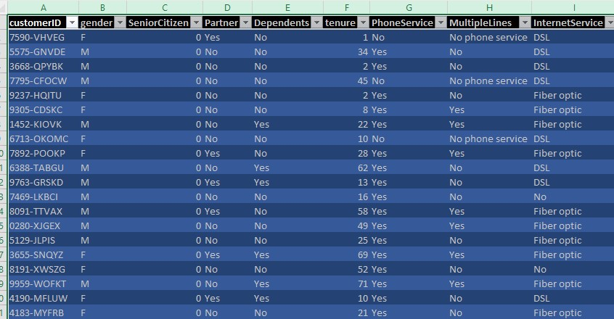
COLUMN NAME | DESCRIPTION | DATA TYPE
Customer ID | Unique identification number for each customer | Text
 | Gender of the customer
  Gender
  Text
Senior Citizen | Indicates whether the customer is a senior citizen (0 = No, 1 = Yes) | Integer
Partner | Indicates whether the customer has a partner | Text
Dependents | Indicates whether the customer has dependents | Text
Tenure | Number of months the customer has stayed with the company | Integer
 | Indicates whether the customer has phone service | Text
  Phone Service
 | Indicates whether the customer has multiple phone lines | Text
  Multiple Lines
 | Type of internet service used by the customer
  Internet Service
  Text
Online Security | Indicates whether the customer has online security service
  Text
Online Backup | Indicates whether the customer has online backup service
  Text
 | Indicates whether the customer has device protection service
  Device Protection
  Text
 | Indicates whether the customer has technical support service
  Tech Support
  Text
 | Indicates whether the customer uses streaming TV service
  Streaming TV
  Text

4. DATA CLEANING & PREPROCESSING
4.1 IMPORTING DATA INTO EXCEL
The dataset was first imported into Microsoft Excel.The Excel workbook containing the Indian Traffic Violations dataset was opened,and the data was placed in a worksheet for further cleaning and analysis.
4.2 ADJUSTING COLUMN WIDTH AND ROW HEIGHT
The column widths and row heights were adjusted to improve the readability and visibility of the dataset.
AutoFit Column Width → Alt + H + O + I
AutoFit Row Height → Alt + H + O + A
4.3 REPLACING VALUES WITH ABBREVIATIONS
Categorical values such as “Female” and “Male” were standardized by replacing them with the abbreviations “F” and “M”. This made the dataset more consistent and easier to analyze.
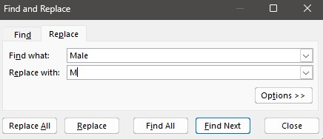
Press Ctrl + H → Enter Male in “Find what” → Enter M in “Replace with” → Click “Replace All”.

5. PIVORT TABLE AND CHART
1.What is the overall distribution of customers who churned and those who stayed with the company?
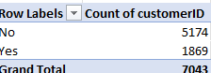
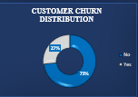
INTERPRETATION:
The chart shows that 73% of customers did not churn, while 27% of customers churned. This indicates that the majority of customers are retained, but more than one-fourth of the customer base has left the company. Therefore, reducing the churn rate should be an important business priority.

2. Which contract type has the highest number of customers?
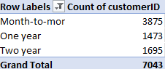
INTERPRETATION:
The chart shows that Month-to-month contracts have the highest number of customers, followed by Two-year and One-year contracts. This indicates that a large portion of customers prefer flexible, short-term contracts. Month-to-month customers may also require more attention because they can switch providers more easily.

3.How does the number of churned customers vary across different payment methods?
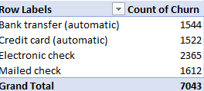
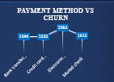
INTERPRETATION:
The chart shows that Electronic check has the highest number of churned customers (2365) among the payment methods shown. Bank transfer, Credit card, and Mailed check have comparatively lower values. This suggests that customers using electronic checks may require further analysis to understand the reasons behind their higher churn.

4.Which payment method is most commonly used by customers?
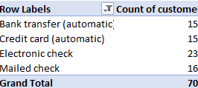
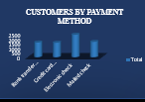
INTERPRETATION:
The chart compares the total number of customers using different payment methods. Electronic check has the highest number of customers, while the other payment methods have comparatively fewer customers. This indicates that electronic check is a major payment channel and should be closely monitored for customer retention and payment-related issues.

5.What is the distribution of customers based on gender?
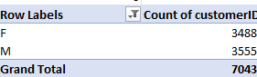
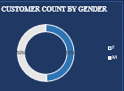
INTERPRETATION:
The chart shows that the customer base is almost equally distributed between female and male customers. There is no significant difference in the number of customers by gender. Therefore, gender does not appear to create a major imbalance in the overall customer population.

6.How do monthly charges vary across different internet service types?
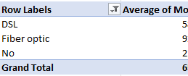
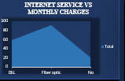
INTERPRETATION:
The chart indicates that Fiber optic customers have the highest monthly charges, followed by DSL, while customers with No internet service have the lowest monthly charges. This suggests that internet service type has a noticeable relationship with monthly customer charges, with fiber-optic services generating higher monthly revenue per customer.

7.How do monthly charges vary across different contract types?
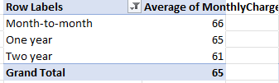
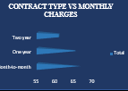
The chart shows that Month-to-month contract customers have the highest monthly charges, followed by One-year and Two-year contract customers. This indicates that customers with shorter-term contracts tend to have higher monthly charges compared with customers on longer-term contracts.

8.How does online security service relate to customer churn?
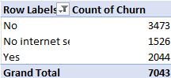
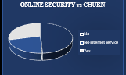
INTERPRETATION:
The chart compares customers based on their online security service and churn status. It helps identify whether customers with or without online security are more likely to churn. Customers without online security appear to have a higher tendency toward churn.

9.How are customers distributed across different internet service types?
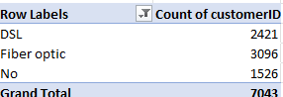
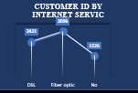
INTERPRETATION:
The chart shows that Fiber optic has the highest customer count (3,096), followed by DSL (2,421), while customers with No internet service have the lowest count (1,526). This indicates that fiber optic is the most commonly used internet service among the customers.

10.How does customer distribution vary based on partner status?
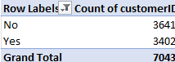
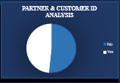
INTERPRETATION:
The chart shows the distribution of customers based on whether they have a partner or not. The customer groups are relatively divided between customers with partners and customers without partners, indicating that partner status is an important demographic characteristic to consider when analyzing customer behavior.
SLICER
A Slicer is an interactive filtering tool in Excel that allows users to quickly filter data in a PivotTable or PivotChart.
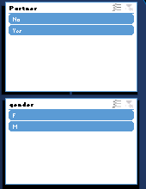

CONCLUSION
The Customer Churn Analysis helps us understand customer behavior and identify the factors that influence churn. The analysis shows that contract type, payment method, internet service, and monthly charges are important factors affecting customers. These insights can help the company identify customers at risk of leaving, improve customer satisfaction, and develop better retention strategies. Overall, the project supports better decision-making and helps the company reduce customer churn and improve long-term customer loyalty.

